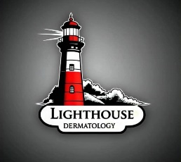**Lighthouse Dermatology**

**Referral Form**

***Please Fax form to:* 586-238-2151 or call for an appointment: 248-726-7646**

|  |  |
| --- | --- |
| Requesting Provider |  |
| Name: |
|  |
| Phone # |
| Fax # |
| Facility: |
| Patient information |  |
|  | Name: |
|  | Gender |
|  | DOB |
|  | Phone # |
|  | Email |
|  | PCP (if different from referring provider) |
| Insurance (please attach copy of insurance card) |  |
| Appointment request | ⃝ Emergent (please call clinic)  ⃝ Urgent (within 1 week)  ⃝ routine  ⃝ referral only, necessary for insurance, Patient not seen  ⃝ other |
| Reason for referral | If referring for a biopsy proven skin cancer, please include a copy of the pathology report and image/picture if available |